Cadence Installation on RHEL 7.9

IP Address: 103.24.97.231

Port: 8392

1. Copy the startup file to your home directory:

**cp /merledu1/cadence/cshrc ~/.cshrc**

|  |
| --- |
| **[zrkhan@merl-HP-Z840 ~]$ cp /merledu1/cadence/cshrc ~/.cshrc** |

1. Change the shell from **bash** to **csh** using the following command:

**chsh -s /bin/csh**

|  |
| --- |
| **[zrkhan@merl-HP-Z840 ~]$ chsh -s /bin/csh**  **Changing shell for zrkhan.**  **Password:**  **Shell changed.** |

1. Logout with **exit**

|  |
| --- |
| **[zrkhan@merl-HP-Z840 ~]$ exit**  **logout** |

1. Log back in which should display the following message:

|  |
| --- |
| **Last login: Mon Mar 8 19:37:47 2021 from 192.168.200.39**    **\*\*\*\*\*\*\*\*\*\*\*\*\*\*\*\*\*\*\*\*\*\*\*\*\*\*\*\*\*\*\*\*\*\*\*\*\*\*\*\*\*\*\*\*\*\*\*\*\*\*\*\*\*\***  **\*\*\*\*\*\* Welcome to Cadence Tools \*\*\*\*\*\*\***  **\*\*\*\*\*\*\*\*\*\*\*\*\*\*\*\*\*\*\*\*\*\*\*\*\*\*\*\*\*\*\*\*\*\*\*\*\*\*\*\*\*\*\*\*\*\*\*\*\*\*\*\*\*\***    **[zrkhan@merl-HP-Z840 ~]$** |

1. To access RHEL using vncviewer, type:

**vncserver -geometry 1366x768 -depth 24**

NOTE: Don’t just type ***vncserver*** instead type the full command. You can also use 1920x1080 instead of 1366x768

|  |
| --- |
| **[zrkhan@merl-HP-Z840 ~]$ vncserver -geometry 1366x768 -depth 24**  **New 'merl-HP-Z840:2 (zrkhan)' desktop is merl-HP-Z840:2**  **Starting applications specified in /home/zrkhan/.vnc/xstartup**  **Log file is /home/zrkhan/.vnc/merl-HP-Z840:2.log** |

1. Invoke using the following:
   1. For Xcelium, type:

**xrun**

|  |
| --- |
| [**zrkhan@merl-HP-Z840 ~]$ xrun**  **xrun(64): 19.09-s016: (c) Copyright 1995-2020 Cadence Design Systems, Inc.**  **Usage:**  **xrun [options] files**  **File languages: Verilog, SystemVerilog, VHDL, e, System-C, C, C++**  **In addition to the dash options all xmverilog plus options can be used.**  **Options shown below in lowercase can also be entered in uppercase.**  **For example, both -top and -TOP are valid.** |

* 1. For SimVision, type:

**simvision**

|  |
| --- |
| **[zrkhan@merl-HP-Z840 ~]$ simvision**  **simvision(64): 19.09-s016: (c) Copyright 1995-2020 Cadence Design Systems, Inc.**  **txe(64): 19.09-s016: (c) Copyright 1995-2021 Cadence Design Systems, Inc.** |

Which will open the GUI for SimVision:

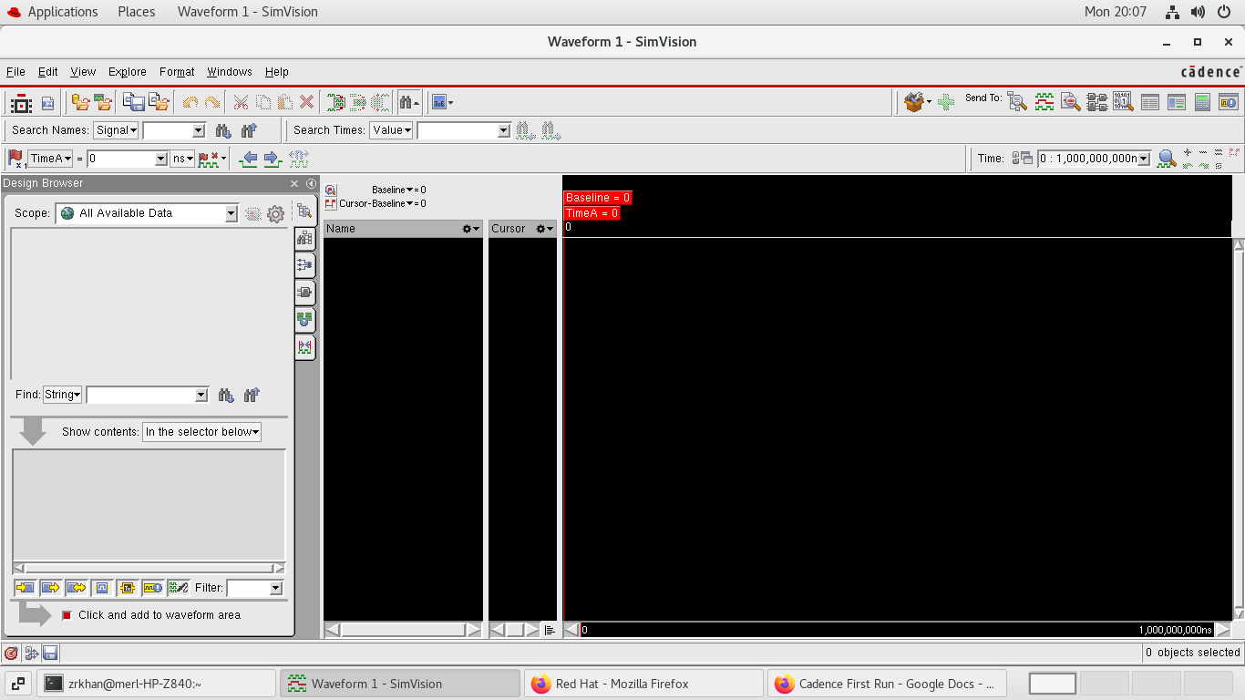

* 1. For Genus, type:

**genus**

|  |
| --- |
| **[zrkhan@merl-HP-Z840 ~]$ genus**  **No DISPLAY environment variable set.**  **GUI mode requires a valid DISPLAY.**  **Reverting to shell mode.**  **TMPDIR is being set to /tmp/genus_temp_2442_merl-HP-Z840_zrkhan_VThL3q**  **Cadence Genus(TM) Synthesis Solution.**  **Copyright 2020 Cadence Design Systems, Inc. All rights reserved worldwide.**  **Cadence and the Cadence logo are registered trademarks and Genus is a trademark**  **of Cadence Design Systems, Inc. in the United States and other countries.**  **Version: 20.10-p001_1, built Fri Dec 11 03:29:55 PST 2020**  **Options:**  **Date: Mon Mar 08 19:45:24 2021**  **Host: merl-HP-Z840 (x86_64 w/Linux 3.10.0-1160.15.2.el7.x86_64) (6cores*24cpus*2physical cpus*Intel(R) Xeon(R) CPU E5-2620 v3 @ 2.40GHz 15360KB) (263878820KB)**  **PID: 2442**  **OS: Red Hat Enterprise Linux Server release 7.9 (Maipo)**  **Checking out license: Genus_Synthesis**  **\*\*\*\*\*\*\*\*\*\*\*\*\*\*\*\*\*\*\*\*\*\*\*\*\*\*\*\*\*\*\*\*\*\*\*\*\*\*\*\*\*\*\*\*\*\*\*\*\*\*\*\*\*\*\*\*\*\*\*\*\*\*\*\*\*\*\*\*\*\*\*\*\*\*\*\*\*\*\*\*\*\*\*\*\*\*\*\*\*\*\*\*\*\*\*\*\*\*\*\*\*\*\*\*\*\*\***  **\*\*\*\*\*\*\*\*\*\*\*\*\*\*\*\*\*\*\*\*\*\*\*\*\*\*\*\*\*\*\*\*\*\*\*\*\*\*\*\*\*\*\*\*\*\*\*\*\*\*\*\*\*\*\*\*\*\*\*\*\*\*\*\*\*\*\*\*\*\*\*\*\*\*\*\*\*\*\*\*\*\*\*\*\*\*\*\*\*\*\*\*\*\*\*\*\*\*\*\*\*\*\*\*\*\*\***  **Loading tool scripts...**  **Finished loading tool scripts (10 seconds elapsed).**  **@genus:root: 1>** |

For accessing through GUI, type the following in the genus console:

**gui_show**

|  |
| --- |
| **@genus:root: 1> gui_show** |

Which will open the GUI for Genus:

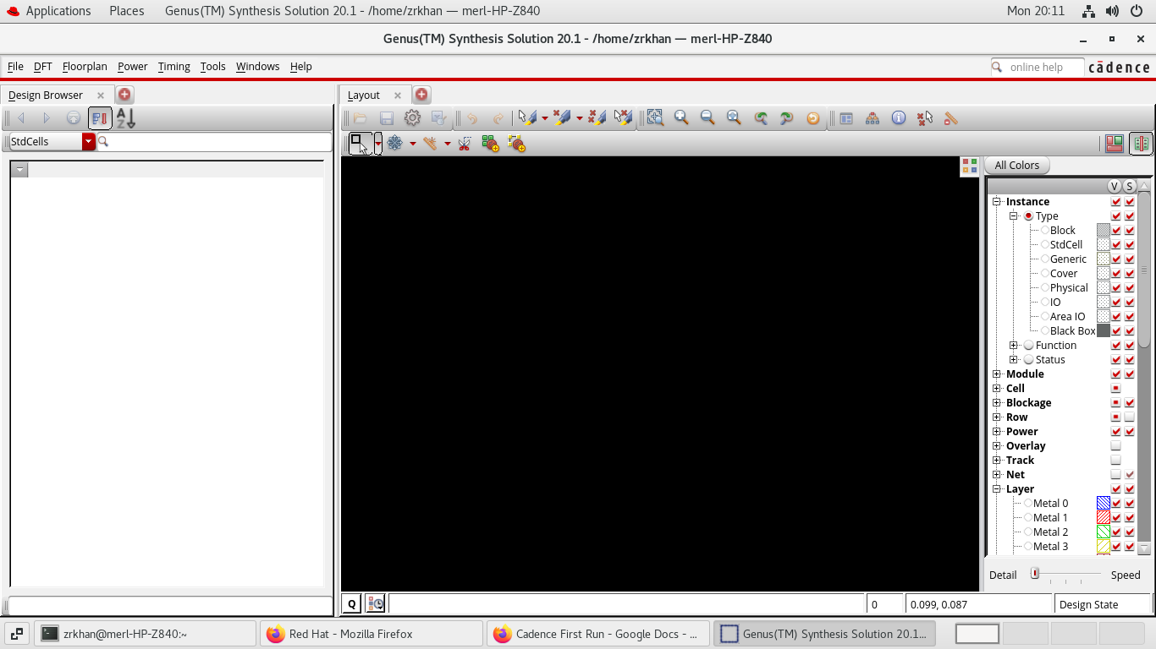

* 1. For Innovus, type:

|  |
| --- |
| **[zrkhan@merl-HP-Z840 ~]$ innovus**  **Cadence Innovus(TM) Implementation System.**  **Copyright 2020 Cadence Design Systems, Inc. All rights reserved worldwide.**  **Version: v20.10-p004_1, built Thu May 7 20:02:41 PDT 2020**  **Options:**  **Date: Mon Mar 8 20:13:08 2021**  **Host: merl-HP-Z840 (x86_64 w/Linux 3.10.0-1160.15.2.el7.x86_64) (6cores*24cpus*Intel(R) Xeon(R) CPU E5-2620 v3 @ 2.40GHz 15360KB)**  **OS: Red Hat Enterprise Linux Server release 7.9 (Maipo)**  **License:**  **invs Innovus Implementation System 20.1 checkout succeeded**  **8 CPU jobs allowed with the current license(s). Use setMultiCpuUsage to set your required CPU count.** |

Which will open the GUI for Innovus:

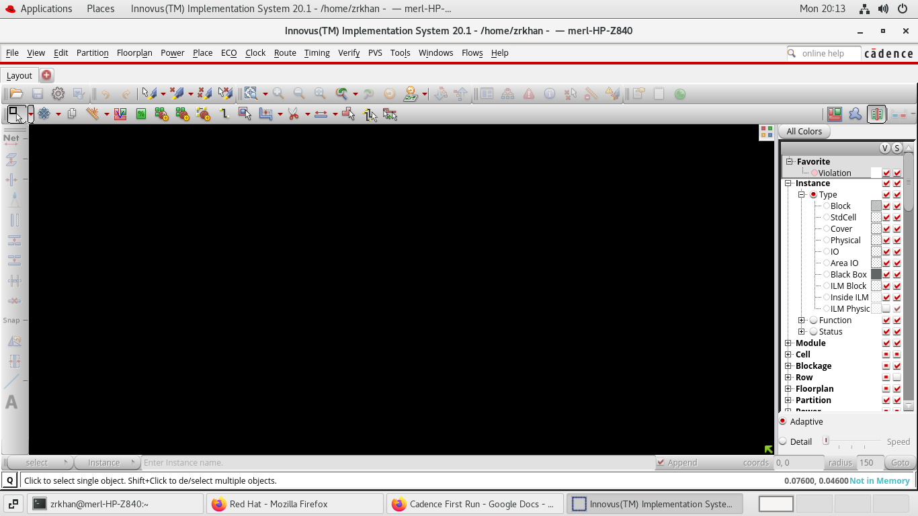

*A generic 45nm PDK is installed at /merledu1/pdks/gpdk045_v_6_0